**Neurofanos**

BraTS Challenge Survey Report

Ali Fazeli

|  |  |  |
| --- | --- | --- |
|  |  | a.fazeli95@gmail.com |

|  |
| --- |
| Table of Contents |
| 1. Introduction. 3 2. Checking the Ingredients 3   Dataset 3  Dataset Visualization 4  Class Imbalance 5  Dataset Augmentation 5  Data Processing 5   1. Architecture Review 6   Transformer + UNet 6  Advantages. 6  Disadvantages. 7  V-Net: FCNN for Volumetric Medical Image Segmentation 7  Disadvantages. 8  R-CNNs 8  3D U-NET 9   1. Infrastructure 10 2. Miscellaneous Findings 11   3D Slicer 11  fastMRI Dataset 11  BrainChop 12   1. Workflow 13 2. Future Work 14 |

|  |
| --- |
| Introduction. |

Objective is warming up by surveying various approaches of Brain tumour segmentation from Magnetic Resonance Imaging using multi- modal brain images, which seems be main characteristic of the great challenge of **BraTS**. This was considered due to various reasons such as availability of dataset, existing research, and my personal interest to work with a 3D segmentation problem and analyse various methods of solving it. Thus, this would be an on-going work on surveying in recent best practices, wrangling around with the feasible models and other kind of stuff that can empower me, myself and I in order to contribute more effectively in the forthcoming competition.

**Github Repo** (Private): <https://github.com/alifzl/Mokh>

**Disclaimer**:

* Following is my personal understanding of BraTS challenge context in roughly one week.
* Many of comments may and may not be accurate.

a.k.a , Don’t kick me out of the group only because I’m a noob.

* Sorry for bad English

# Checking the Ingredients

This section is gonna be the preliminary before the flight checks section.

## Dataset

Dataset consists of multi-institutional pre-operative MRI scans and primarily focuses on the segmentation of intrin- sically heterogeneous (in appearance, shape, and histology) brain tumors, namely **gliomas**. All BraTS multimodal scans are available as **NIfTI** files (.nii.gz) and describe a) native (T1) and b) post-contrast T1-weighted (T1Gd), c) T2-weighted (T2), and d) T2 Fluid Attenuated Inversion Recovery (T2-FLAIR) volumes, and were acquired with different clinical protocols and various scanners from multiple (n=19) institutions, mentioned as data contributors here. All the imaging datasets **have been segmented manually**, by one to four raters, following the same annota- tion protocol, and their annotations were approved by experienced neuro-radiologists. Annotations comprise the GD-enhancing tumor, the peritumoral edema and the necrotic and non-enhancing tumor core (NCR/NET), as described both in the BraTS 2012-2013 TMI paper and in the latest BraTS summarizing paper.

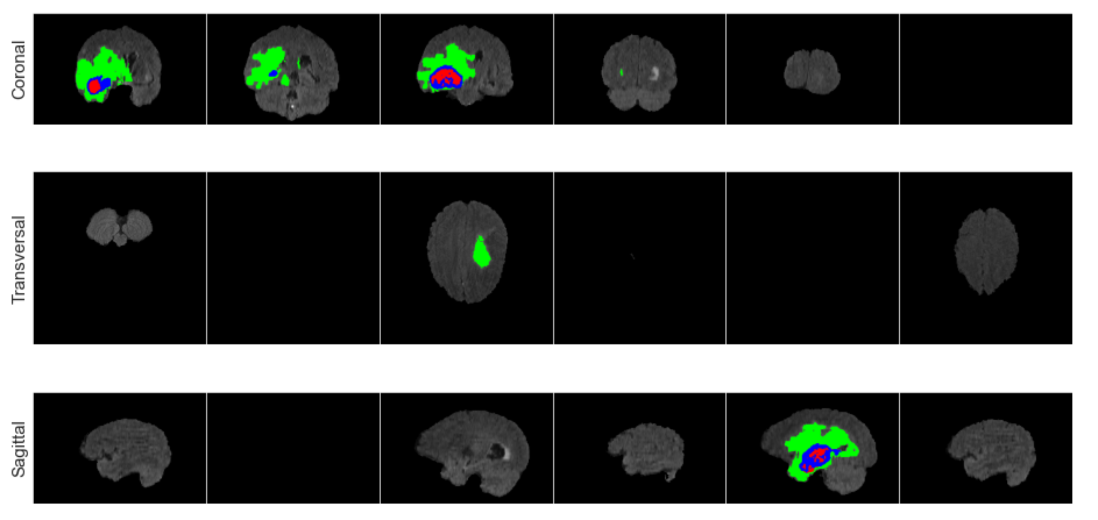

Also I’ve learned the different angle types of brain imaging.

* Transversal: Horizontal
* Coronal: separates the brain into anterior and posterior halves.
* Saggital: divides the right and left side of the brain into parts

## Dataset Visualization

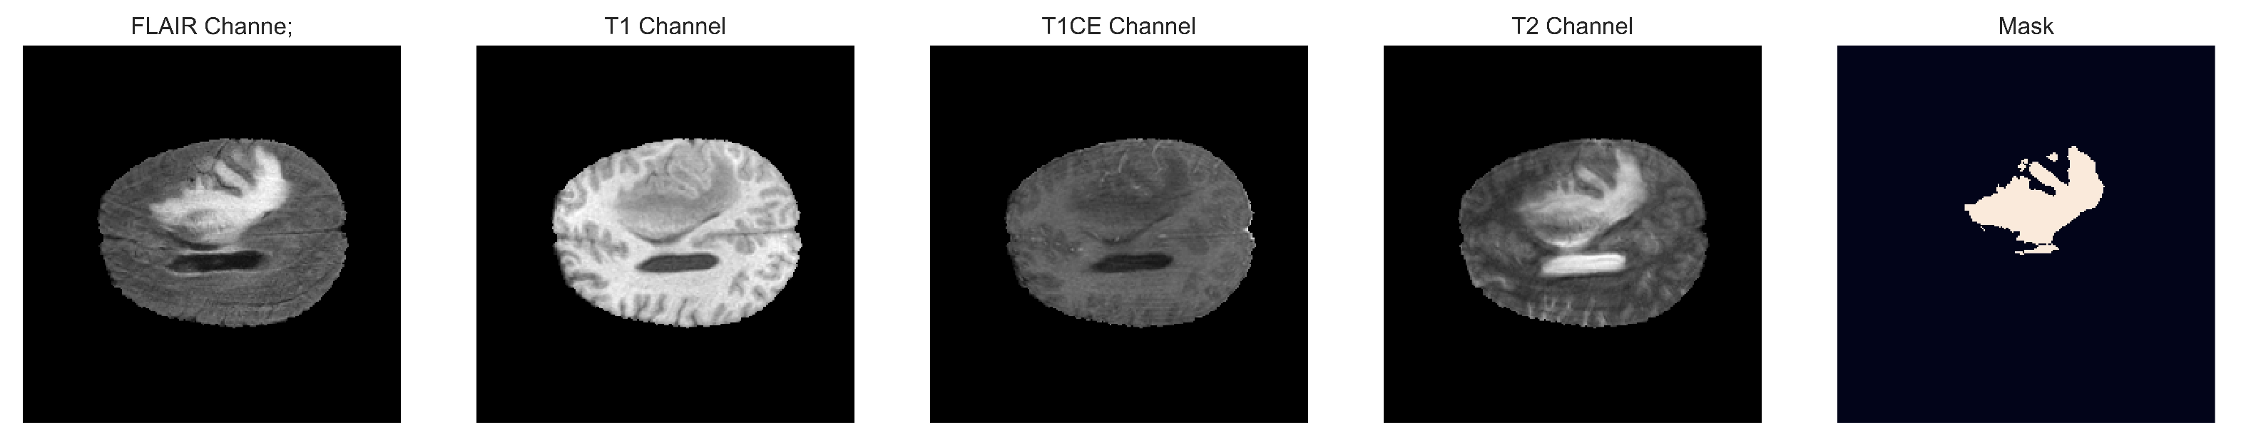

A great library which I came across was [Nilearn](https://nilearn.github.io/stable/index.html)**.** I found a great utils function using this library which can help in doing exploratory data analysis stage. Can be found in utils.py in forementioned github repository.

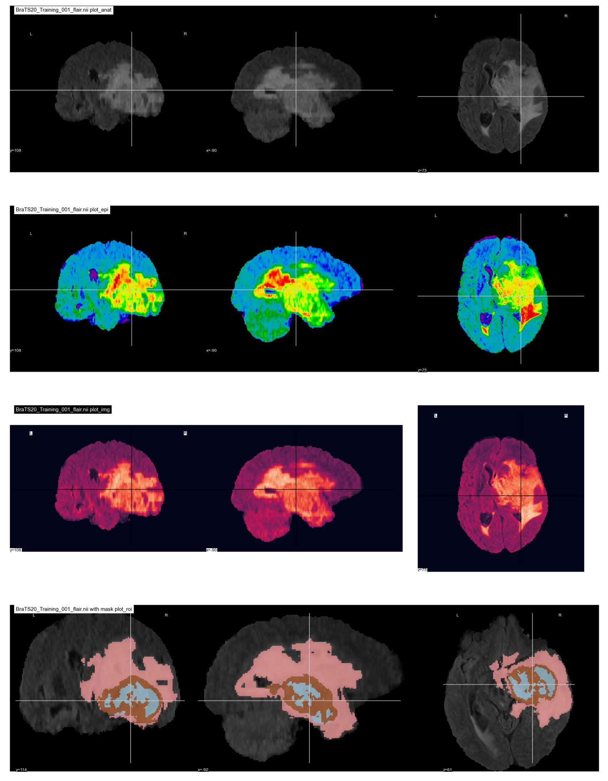

## Class Imbalance

Prevalence of some conditions (frequency of particular cases being significantly more than others), leading to imbalance in the trainset causing those classes to contribute more towards the loss. This leads to the model to train with priority given to these classes, neglecting the other classes. So, the model will only be able to predict conditions related to the majority classes with greater accuracy and other minority classes with very poor accuracy.

|  |  |
| --- | --- |
|  | * Can be resolved with weighted loss (the use of Binary cross-entropy loss assigned with weights). * Could also be resolved by resampling but it is deprecated |

## Dataset Augmentation

* Rotating, shifting, scaling, intensity, contrast change.
* Color noise
* Flipping & inversion is deprecated as it changes the spatial orientation & labels of the 3D images.

## Data Processing

For this matter I found [MONAI](https://docs.monai.io/en/latest/index.html) interesting. MONAI is a PyTorch-based, open-source framework for deep learning in healthcare imaging. And it could be used for our controversial data pre/post processing tasks such as transforming, model bundling and inference.

# Architecture Review

From a few days searching and naïve thinking, I concluded breaking the problem into 2D problem of multiple slices but that would lead to loss of context and information between the slices along with intensive effort in image registration; breaking it into smaller 3D units (voxels), that would also lead to loss of information but using cross validation and hyperparameter tuning of the sub-unit dimensions, a desirable result could be achieved. I reviewed multiple research papers and shortlisted a few of them for their techniques. I plan to use the 3D U-Net Architecture.

## Transformer + UNet

Due to the limitation of convolution kernel size, **each convolution kernel only focuses on local information**. Therefore, it is difficult for these existing methods to generate any long-distance dependencies when performing image segmentation tasks. The ability to construct global contextual information is crucial for intensive prediction tasks during medical image segmentation. To effectively address the issues on global contextual information, **Transformer** was proposed to **handle the issues in sequence-to-sequence prediction**.

A one-dimensional sequence is taken as input, so Transformer has a powerful modelling ability, not only in constructing global context information. But it only focuses on building global context information at all stages. Therefore, its ability to obtain local information is weakened, and the lack of detailed location information encoding reduces the distinguishability between background and target. **UNet provide a way to extract low-level visual information, which can well compensate for the spatial details of Transformer’s local information.**

**TransUNet first used CNNs to extract local features, and then applied Transformer to global context modelling**. This architecture not only establishes a self-attention mechanism, but also reduces the loss of local feature resolution brought by Transformer, making it have better image segmentation accuracy. The low-dimensional image texture features mainly include structural features and statistical features.

The proposed hybrid network is divided into **five stages. Stem is the first stage. CNNs and Transformer alternate in the remaining four stages**. At the beginning of each stage, downsampling is applied to decrease feature map size and increase the number of channels. Additionally, the proposed network refers to the residual connection of ResNet.

Specifically, stem as the first stage contains two layers of simple 3×3 convolution. CNNs stage is the second stage, because the feature map is too large at this moment and not suitable for using Transformer in global feature extraction. The CNNs stage uses a **Depthwise Separable Convolution block (DSConv)** to reduce the amount and size of model parameters. There is a 1×1 convolution layer before and after DSConv to change the feature map size and the number of channels. The third stage is the Transformer stage, which extracts global features after CNNs. The proposed network adopts a lightweight multi-head self-attention. In order to reduce the overhead, the proposed network uses **a k×k depthwise convolution with a stride of k to reduce the dimensions**.

## Advantages.

|  |  |
| --- | --- |
|  | *U-Net model can perform efficient segmentation of images* ***using limited number of labelled training images****.*  *U-Net architecture* ***combines the location information obtained from the downsampling path and the contextual information obtained from upsampling path*** *to predict a fair segmentation map.* |

## Disadvantages.

|  |  |
| --- | --- |
|  | * *Input image size is limited.* * *In the middle layers of deeper UNET models, the learning generally slows down which causes the network to ignore the layers with abstract features.* * *The skip connections of the model impose a restrictive fusion scheme which causes accumulation of the same scale feature maps of the encoder and decoder networks.* * *Reference:* [*https://doi.org/10.3389/fnins.2022.1009581*](https://doi.org/10.3389/fnins.2022.1009581) |

## V-Net: FCNN for Volumetric Medical Image Segmentation

Refrains from processing the input volumes slice-wise and propose to use volumetric convolutions instead.

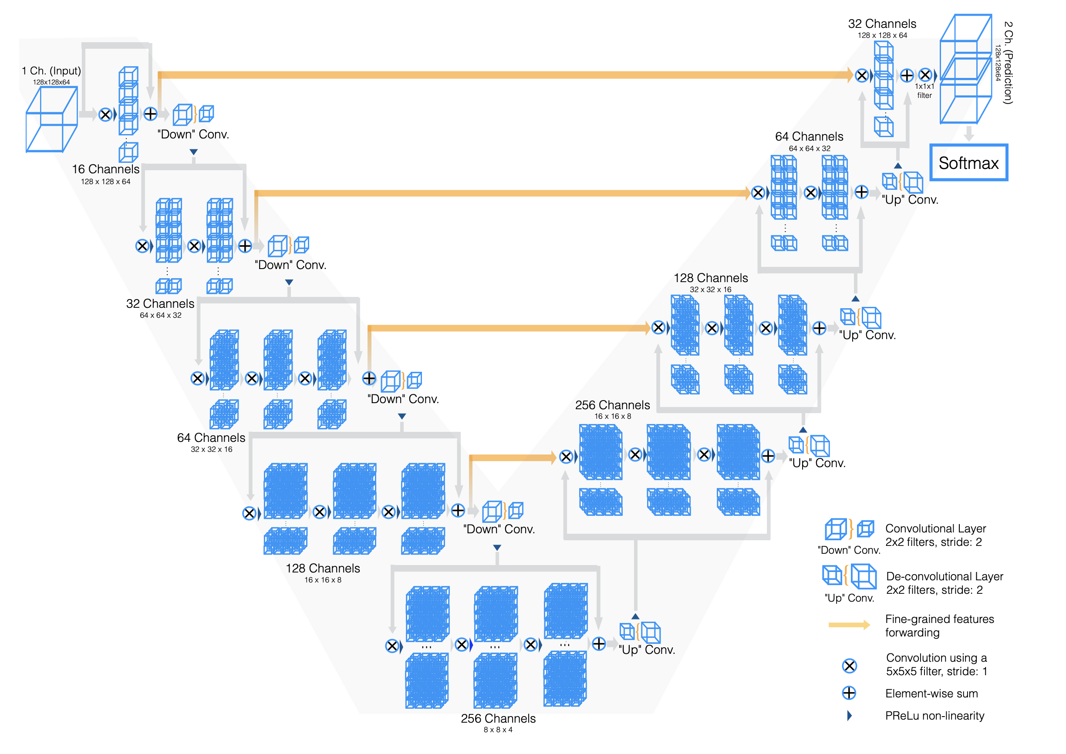

The left part of the network consists of a compression path, while the right part decompresses the signal until its original size is reached. **The left side of the network is divided in different stages that operate at different resolutions. Each stage comprises one to three convolutional layers.** The input of each stage is used in the convolutional layers and processed through the non-linearities and added to the output of the last convolutional layer of that stage in order to enable learning a residual function.

Since the number of feature channels doubles at each stage of the compression path of the V-Net, and due to the formulation of the model as a residual network, we resort to these convolution operations to double the number of feature maps as we reduce their resolution.

**Downsampling allows us to reduce the size of the signal presented as input and to increase the receptive field of the features being computed in subsequent network layers**. Each of the stages of the left part of the network, computes a number of features which is two times higher than the one of the previous layers.

**Replacing pooling operations with convolutional osnes results in a smaller memory footprint during training**, because no switches mapping the output of pooling layers back to their inputs are needed for backpropagation.

**The right portion of the network extracts features and expands the spatial support of the lower resolution feature maps** in order to gather and assemble the necessary information to output a two-channel volumetric segmentation.

## Disadvantages.

|  |  |
| --- | --- |
|  | * *It is not fast for real time inference and it does not consider the global context information efficiently.* * *In FCN, the resolution of the feature maps generated at the output is downsampled due to propagation through alternate convolution and pooling layers.* * *This results in low resolution predictions in FCN with fuzziness in object boundaries* * *References:* [*https://arxiv.org/abs/1606.04797*](https://arxiv.org/abs/1606.04797) |

## R-CNNs

It generates region proposal network for bounding boxes using selective search process. These region proposals are then warped to standard squares and are forwarded to a CNN so as to generate feature vector map as output.

The output dense layer consists of features extracted from the image and these features are then fed to classification algorithm so as to classify the objects lying within the region proposal network. The algorithm also predicts the offset values for increasing the precision level of the region proposal or bounding box.

However, a **huge amount of time is needed to train network to classify 2000 region proposals per image** It cannot be implemented in real time. Selective search algorithm is a fixed algorithm.

As Dear Gonzalo said, **each architecture which have “R” in it, is a No GO**. Just kidding, I’m just an apprentice.

## 3D U-NET

After analysing various factors such as complexity of model, ease of implementation, etc. I decided to implement the 3D U-Net Model.

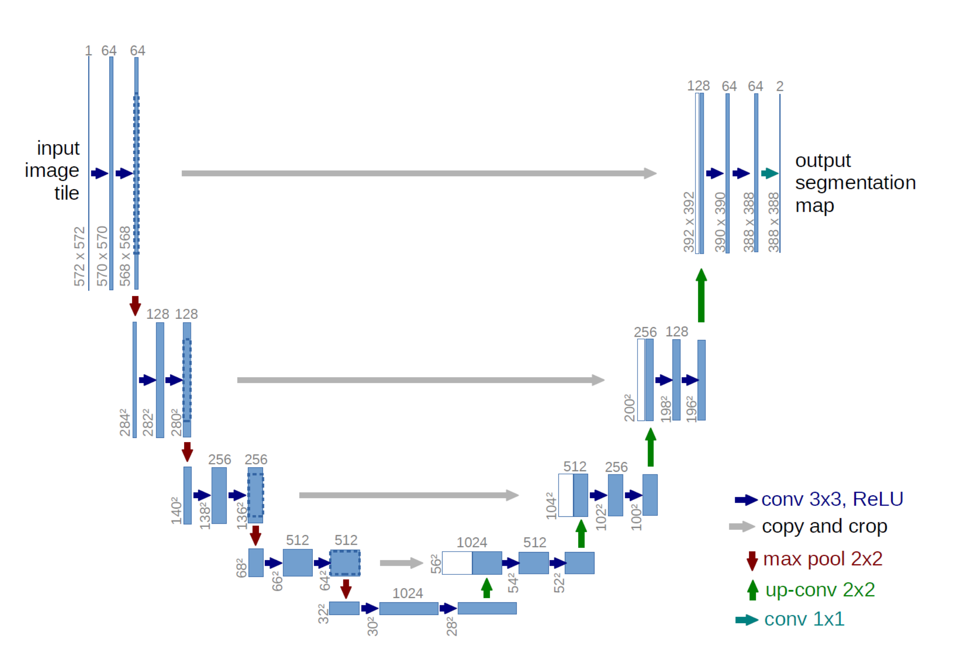

Model Specifications:

|  |  |
| --- | --- |
| Attribute | Value |
| Input size | (128, 128, 128, 3) |
| Output size | (128, 128, 128, 1) |
| Train Cases | 249 |
| Validation Cases | 74 |
| Test Cases | 45 |
| Optimizer | Adam |
| Loss | Categorical cross-entropy, soft dice loss |
| Metric | Accuracy, Dice coefficient, Precision, Dice coefficient enhancing |
| Model Checkpoint Monitor | Validation accuracy |
| Early Stopping Monitor | Validation loss |
| Kernel | he_normal |
| Epochs | 10 |
| Activation | ReLU |
| Callbacks | Model checkpoint, Early stopping |
| Step Size | 20 |
| Batch Size | 1 |
| Learning Rate | 0.001 |
|  |  |

**Issue**:

However, 3D U-Net Model couldn’t be implemented on my system due to GPU capacity limitations which gave Profiling failure on CUDNN engine 1#TC: RESOURCE EXHAUSTED: Out of memory while trying to allocate 18330128 bytes error. I tried fixes such as reducing batch size to 1, reducing input size dimensions, cleared cache & GPU memory, allowed GPU memory allocation growth and other solutions that I could find. The error remained unresolved. **I’ll try again with nesi whenever I was allowed.**

# Infrastructure

As an MLOps Engineer, I’ve pretty decent experience in Deployment and Maintenance of several well-known platforms in this regard such as [Polyaxon](http://polyaxon.com/), [Kedro](http://kedro.org/) and [Prefect](http://prefect.io/). But I assume **there would be no need for us to implement a huge MLOps Infrastructure** for the forthcoming challenge. And the reasons are as below:

1. We don’t need to deploy the model for the production level inference.
2. We don’t want to bother ourselves to figure out how to integrate our R&D code with Model Tracking, autoML and this kind of stuff. (Trust me, majority of perfect platforms out there have significant integration overhead)
3. We only want to preserve each of every experiment/approach for later use. (Do not over-engineer stuff)
4. We’re not corporation with a lot of teams who do Data Engineering, Analyze, etc.

But, as you see in the figure below, we definitely need a tiny workaround for saving the model metadata and results.

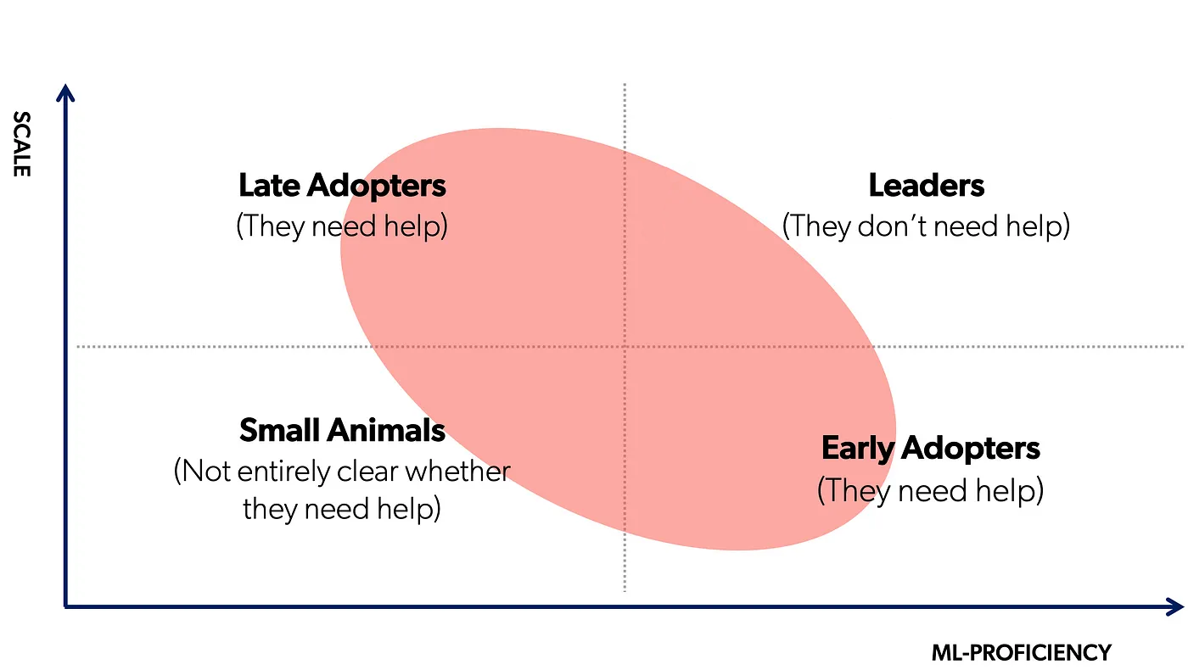



**We Are Here**

Despite of my early suggestion on Facebook’s [Ax](https://ax.dev/) and Microsoft’s [NNI](https://github.com/microsoft/nni), I’d suggest having this cute library called [ModelStore](https://github.com/operatorai/modelstore) installed.

1. Installing **Modelstore** in the environment which you code (`pip install modelstore `) (one time setup)
2. Setting up an AWS S3 Bucket, or I can deploy an on-permise MinIO service (one time setup)
3. Add the needful imports and decorators at your code

**TL;DR**: My suggestion is using [ModelStore](https://github.com/operatorai/modelstore). Besides if you happy with **tensorboard**, these two become very powerful together.

# Miscellaneous Findings

Here is the misc. findings section

## 3D Slicer

A robust application with several capabilities which can help in most of challenge’s Labor work. I found [this extension](https://discourse.slicer.org/t/new-extension-slicerfreesurfer/12751/1) intuitive for check and getting to know several slices at one place. Also there is python scripting module, spatial registration and segmentation capabilities.

## fastMRI Dataset

Data from 6,970 fully sampled brain MRIs obtained on 3 and 1.5 Tesla magnets. The raw dataset includes axial T1 weighted, T2 weighted and FLAIR images. Some of the T1 weighted acquisitions included admissions of contrast agent. The exact distribution of contrasts and field strengths is given in table below:

|  |  |  |  |
| --- | --- | --- | --- |
| **Field Strength** | **1.5T** | **3T** |  |
| T1 | 382 | 409 |  |
| T1 post contrast | 849 | 646 |  |
| T2 | 1655 | 2524 |  |
| FLAIR | 126 | 411 |  |
| Total | 3012 | 3990 | 7002 |

Link: <https://fastmri.med.nyu.edu/>

|  |  |
| --- | --- |
|  | *Unfortunately,* ***dataset is not labeled,*** *but the size of dataset is huge.*  *As I spoke with dear Maral, she said maybe we can use a Encode-Decoder architecture to make use of this dataset.* |

## BrainChop

brings automatic 3D MRI volumetric segmentation capability to neuroimaging by running a deep learning model in the web-browser on the user side.

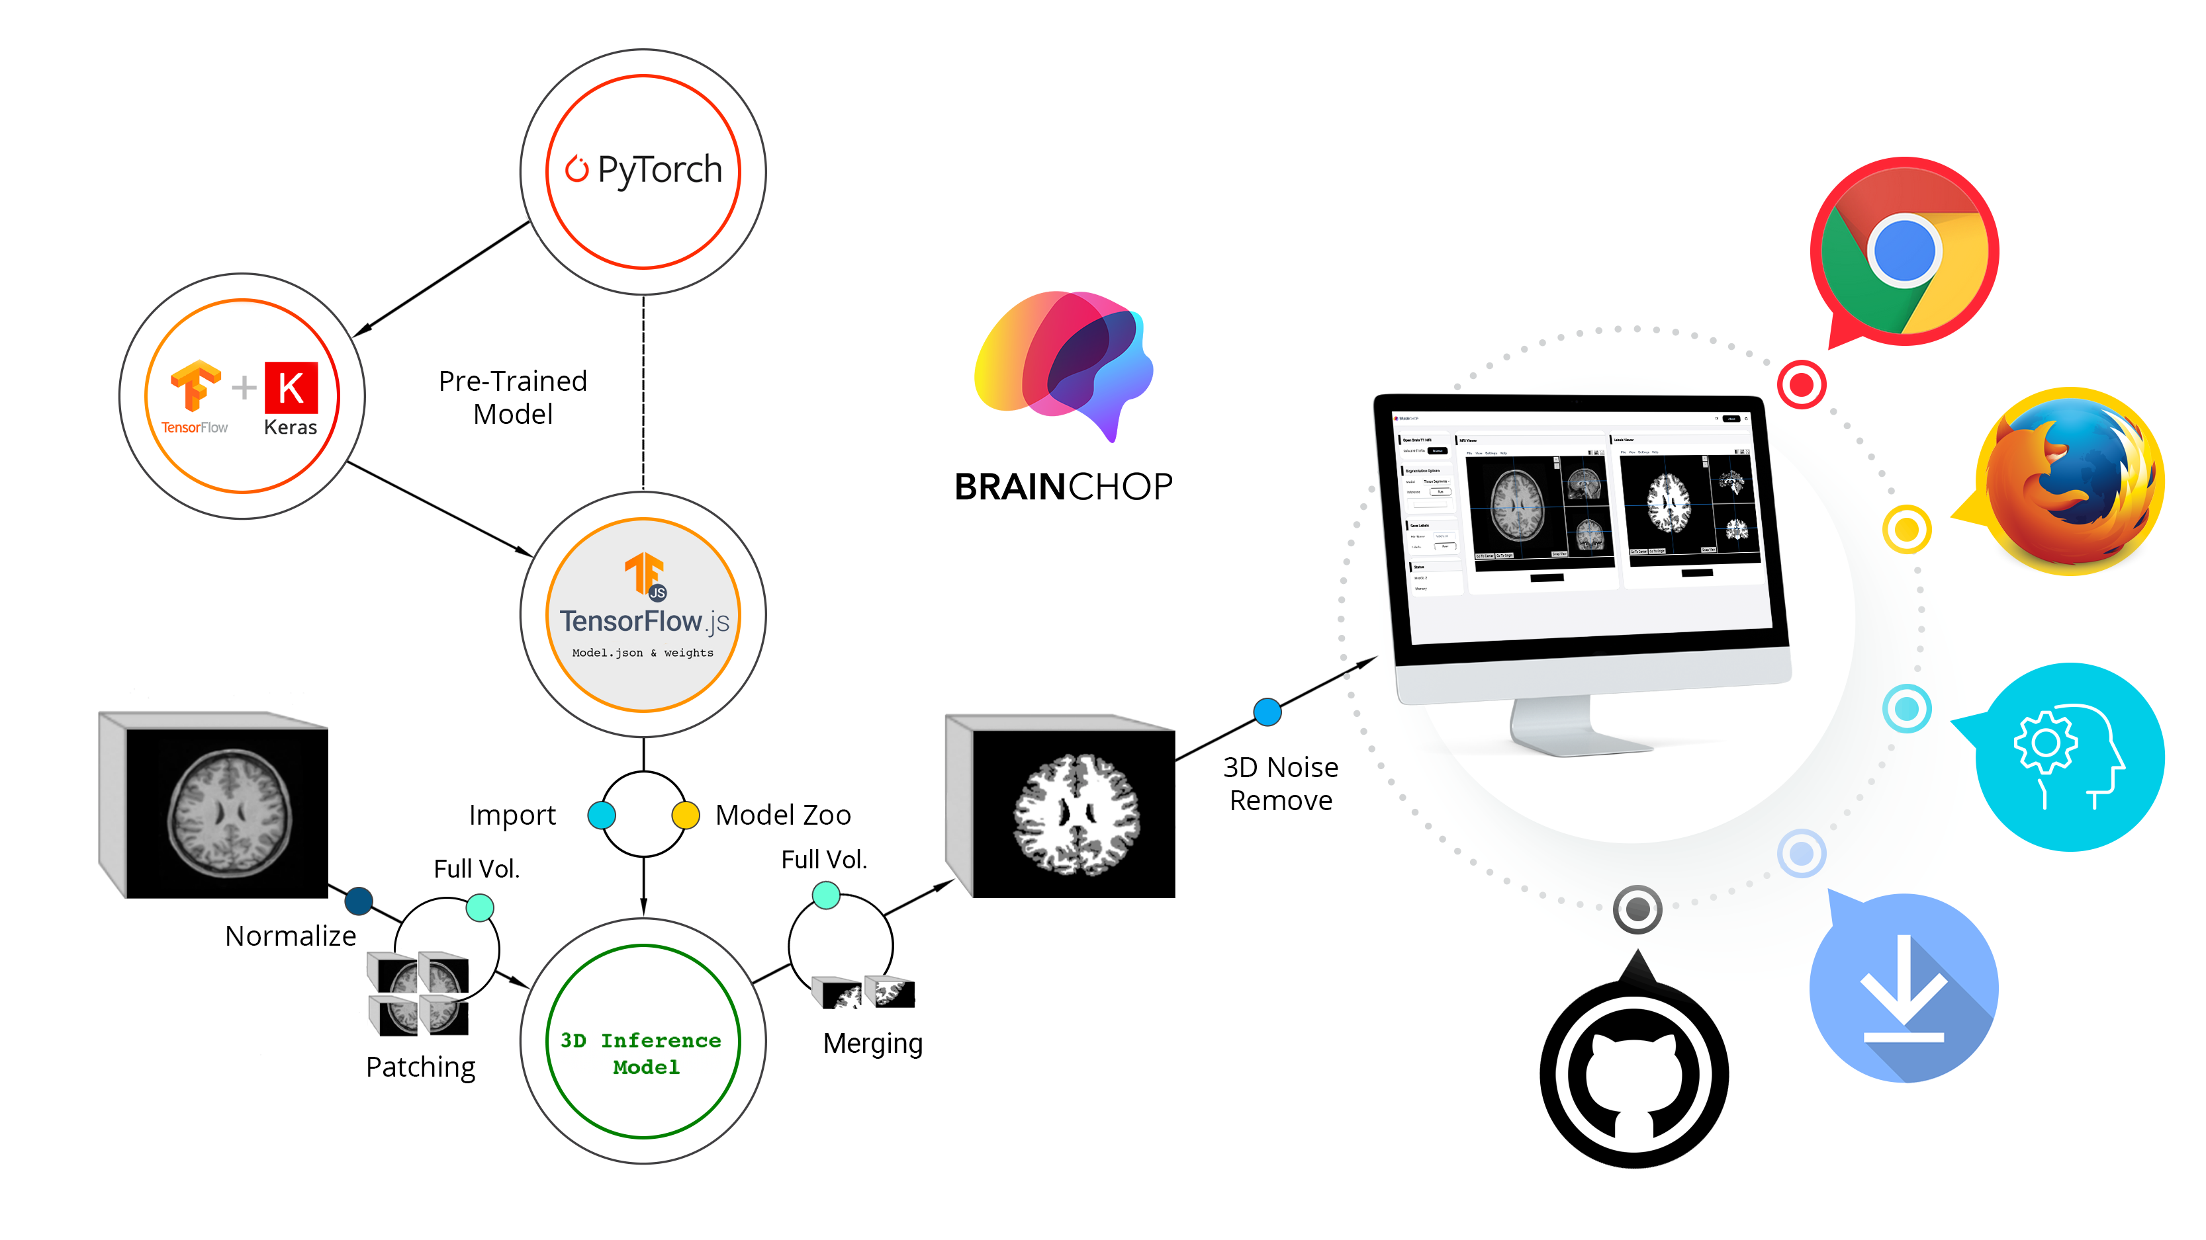

Link: <https://neuroneural.github.io/brainchop/>

# Workflow

How to make data analysis, preprocess data, implement DL Model, check the results and go again.

I found [NiPreps](https://www.nipreps.org/) very close to what we gonna encounter in future.



# Future Work

I’m going to analyze and learn the pros and cons of recent models listed in Medical Image Segmentation Leaderboard of **paperswithcode** website, [linked here](https://paperswithcode.com/task/medical-image-segmentation), in order to gain more knowledge about this fascinating challenge.

